HEALTHCARE Analysis

Week2:
Data Collection and Quality Assurance Planning

- Introduction
In this project, a healthcare dataset containing 55,500 patient records and 15 Data collection is one of the most important steps in any data analysis project. The quality of the collected data directly affects the accuracy of the results. Therefore, before performing analysis, it is necessary to verify that the dataset is complete, consistent, and free from errors.
For this project, a healthcare dataset containing patient information has been selected for analysis.
The selected dataset contains 55,500 records and 15 attributes.

Dataset Features
Column | Description
Name | Patient Name
Age | Patient Age
Gender | Male/Female
Blood Type | Blood Group
Medical Condition | Disease
Date of Admission | Admission Date
Doctor | Doctor Name
Hospital | Hospital Name
Insurance Provider | Insurance Company
Billing Amount | Treatment Cost
Room Number | Room Number
Admission Type | Emergency, Urgent, Elective
Discharge Date | Discharge Date
Medication | Prescribed Medicine
Test Results | Medical Test Results

- Task Objective

This task is designed to evaluate your approach to sourcing, acquiring, and assuring the quality of healthcare data. You will simulate the planning process for data collection and quality control measures in a healthcare setting. This includes understanding public data sources, validating data integrity, and planning for data cleaning processes.

Data Collection Strategy

- Step1: Dataset Selection

A healthcare dataset was selected based on the following criteria:
- Large number of patient records
- Multiple healthcare-related features
- Suitable for data visualization and predictive analysis
- Well-structured and easy to process
- Step2: Data Acquisition

The dataset was downloaded in CSV format and stored on the local computer for further analysis. It was imported into Python using the Pandas library.

- Step3: Data Loading

The dataset was loaded into a jupyter notebook using pandas.

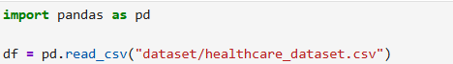

- Step4: Initial Data Inspection
After loading the dataset, the following checks were performed:
- Display the first five records
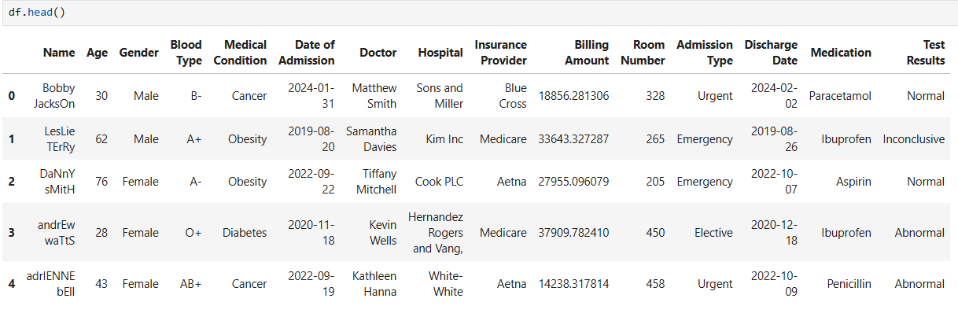
- Check the number of rows and columns
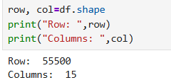
- Verify column names and data types
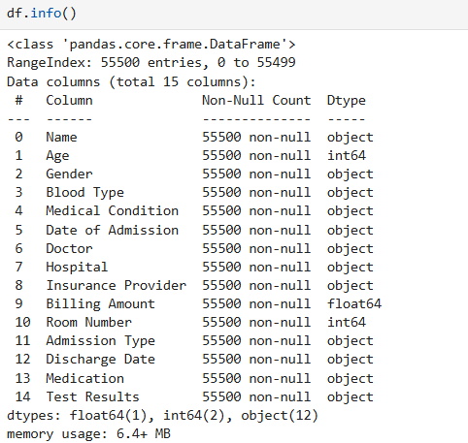
- Review summary statistics
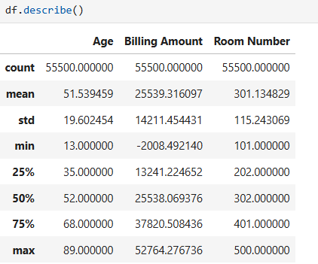

- Step5: Data Validation

The dataset structure was verified by:
- Confirming all required columns are present
All required columns are present
- Checking for missing values
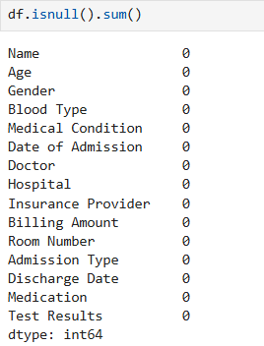
- Identifying duplicate records
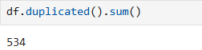
- Ensuring correct data types

There is wrong data types in columns “Data admission, Discharge date” as their data types should be datetime but they are of object.
- Reviewing categorical values for consistency
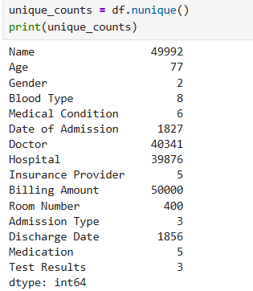
We can see that “Gender”, “Blood type”, “Insurance Provider”, “Admission Type”, “Medication”, “Test Results” are the categorical attributes.

- Step6: Dataset Preparation

Before analysis, the dataset was prepared by:
- Removing duplicate records (if any)
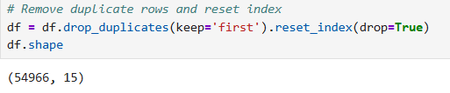
- Handling missing values
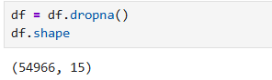
As there is no null values so no change occurs.
- Converting date columns into datetime format
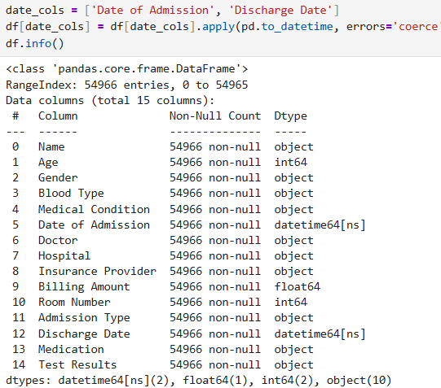
- Validating numerical fields such as Age and Billing Amount
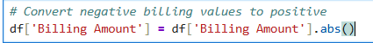

- Step7: Ready For Analysis
After completing these steps, the dataset became ready for:
- Exploratory Data Analysis (EDA)
- Data Visualization
- Statistical Analysis
- Predictive Modeling

Data Quality Assurance

- Step1: Missing Value check

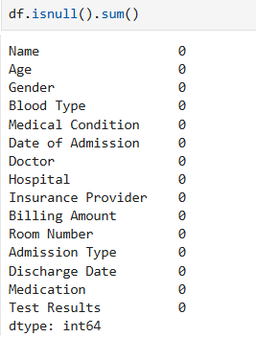

- Step2: Duplicate Record Check

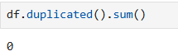

- Step3: Data Type Validation

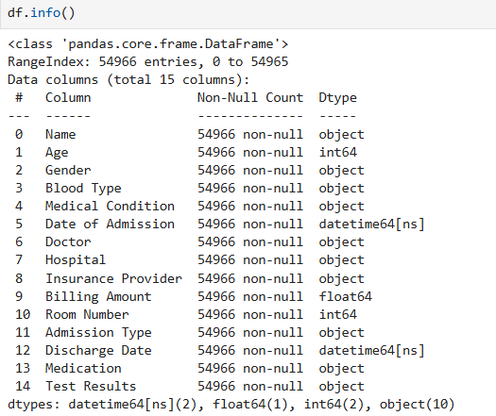
- Step4: Outlier Detection

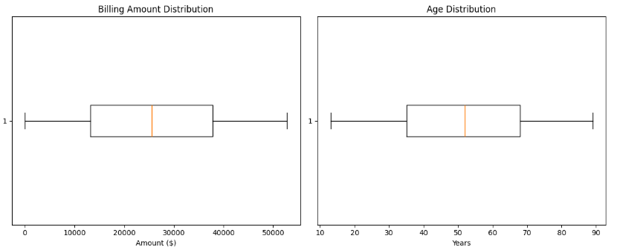
There is no outlier in numerical values

Conclusion

The healthcare dataset successfully passed all major quality assurance checks. No missing values or duplicate records were found, and the dataset contains consistent categorical values with valid numerical data. After validating data types and standardizing the dataset, it is ready for Exploratory Data Analysis (EDA), data visualization, statistical analysis, and predictive modeling in the upcoming stages of the project.

